**PART 3: On AI Agent Integration**

I ask Copilot to review and suggest improvements for my Word Coding ( step 4), and it shows my potential issues with corresponding enhancements, such as time check loop logic, function naming consistency, and weight comparison logic. I also ask for the translation of my pseudocode logic for an automated pet feeder into an actual hardware system. It said that I must use the RTC module to send the current time, combining Arduino for hardware control like handle sensors, motors, timing, and Raspberry Pi for UI, data logging, and remote access. Copilot helps me to define and complete my work with insights logic - system must have another case where the system is not active normally ( Covers edge cases where the weight increases instead of only weight reduction or remains unchanged). Besides, I understood exactly which sensors and modules were necessary and how they would connect logically. In addition, I gained clarity on the strengths and weaknesses of Arduino vs Raspberry Pi, and realised that a hybrid system could deliver both reliable hardware control and advanced remote management.

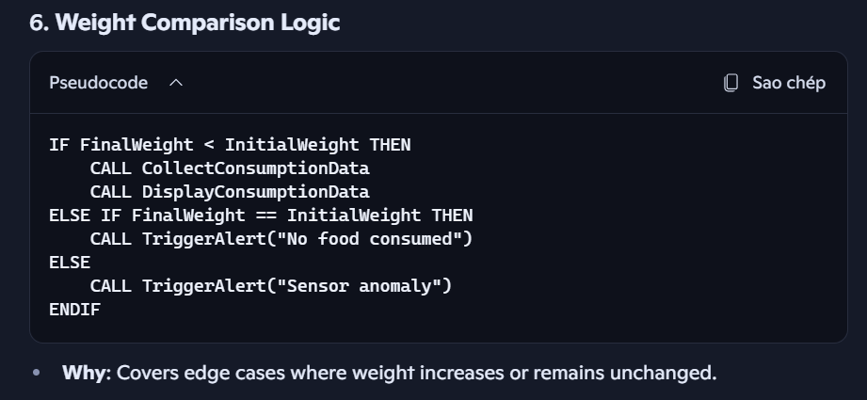

(system must have another case where the system is not active normally)

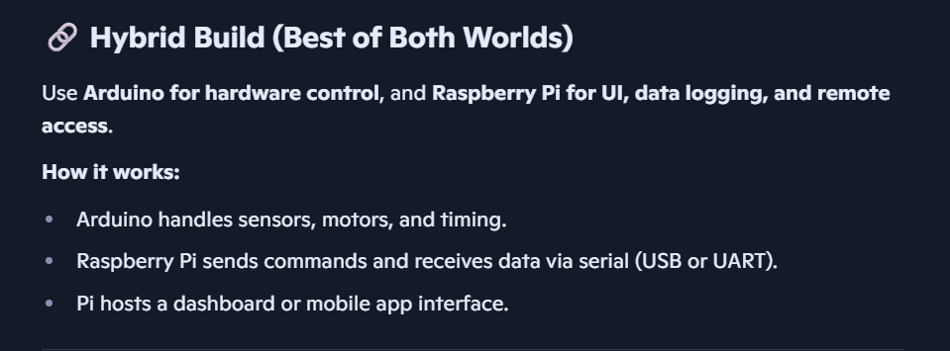

(combine Arduino and Raspberry Pi deliver both reliable hardware control and advanced remote management)

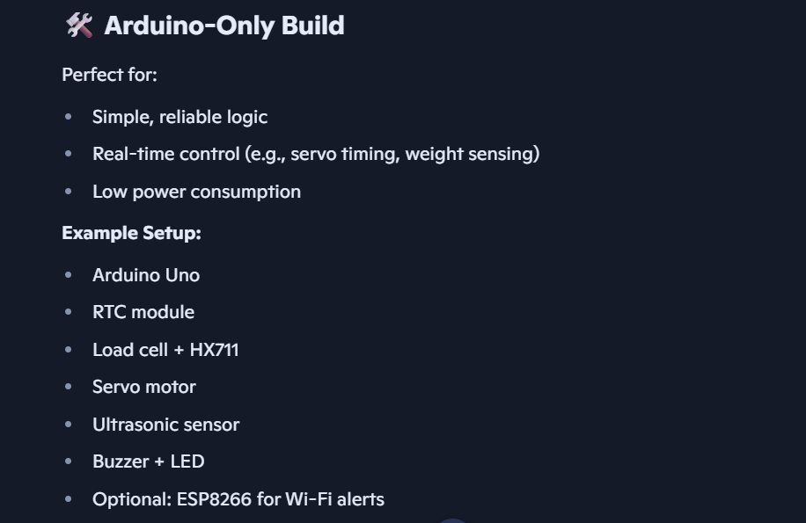

( strengths of Arduino)

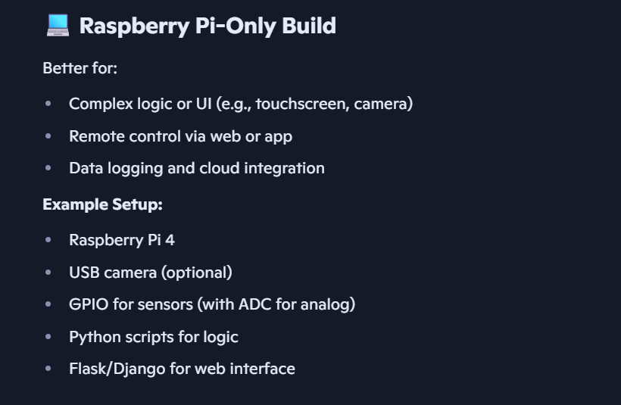

(strengths of Raspberry Pi)